AI ASSISTED CODING
ASSINGMENT-8
NAME: K.POORNACHANDER
HALL.NUMBER:2403A52382
BATCH NUMBER :AI 14
Task Description #1 (Password Strength Validator – Apply AI in Security Context)
- Task: Apply AI to generate at least 3 assert test cases for is_strong_password(password) and implement the validator function.

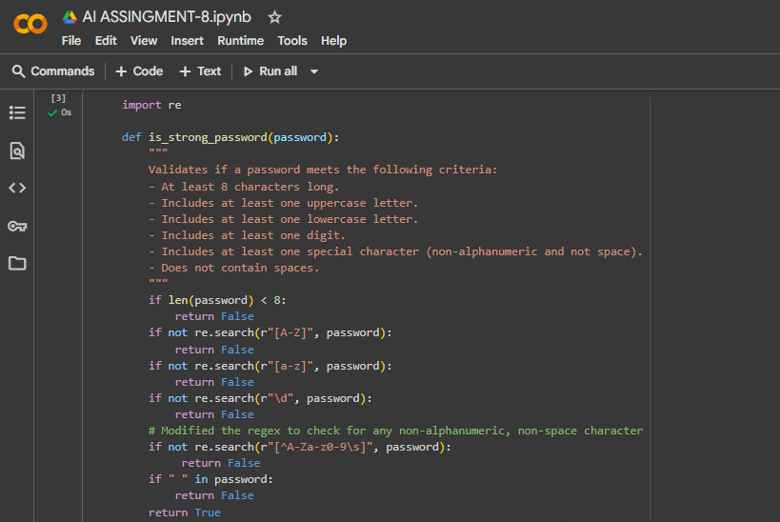

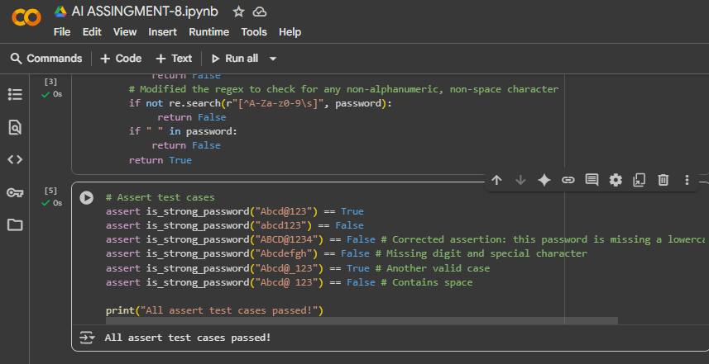
EXPLAINATION:
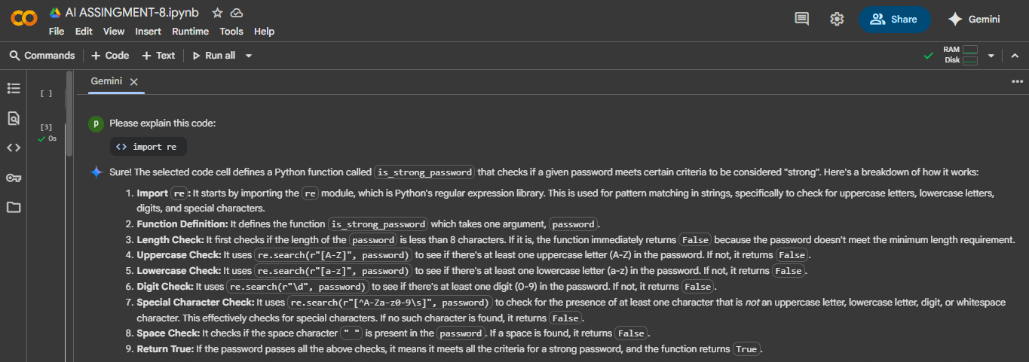

Task Description #2 (Number Classification with Loops – Apply AI for Edge Case Handling)
Task: Use AI to generate at least 3 assert test cases for a classify_number(n) function. Implement using loops.
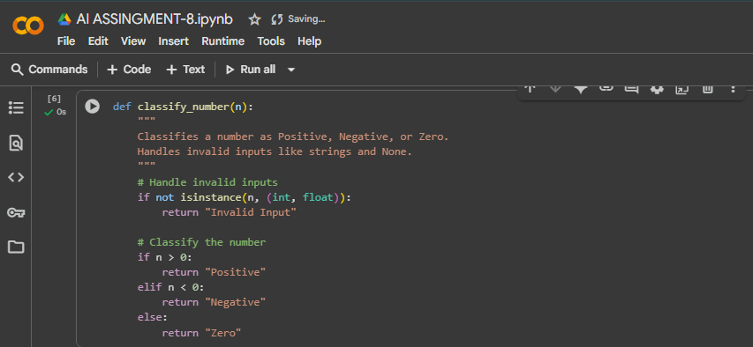
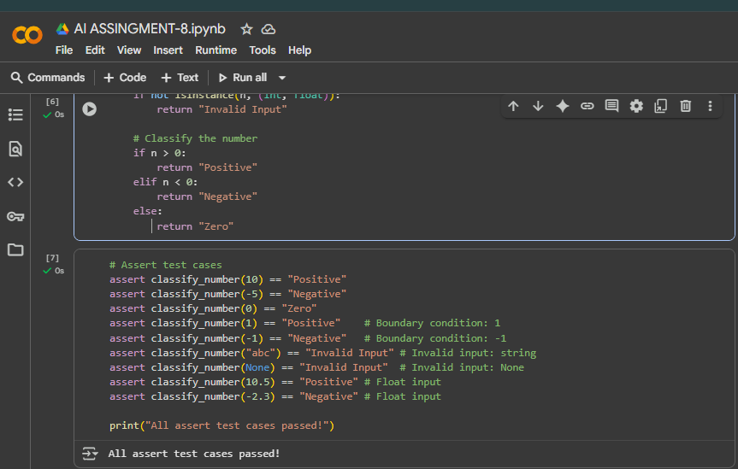
EXPLANITATION:
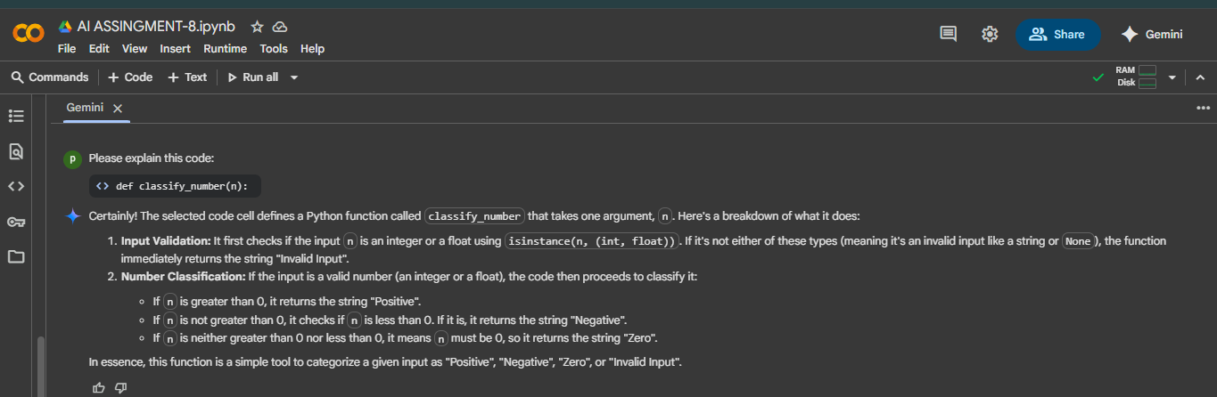

Task Description #3 (Anagram Checker – Apply AI for String Analysis)
- Task: Use AI to generate at least 3 assert test cases for is_anagram(str1, str2) and implement the function.
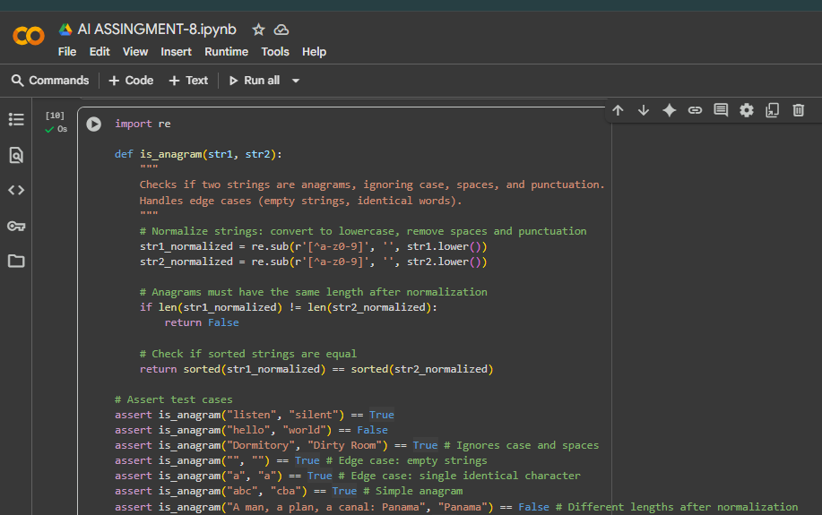
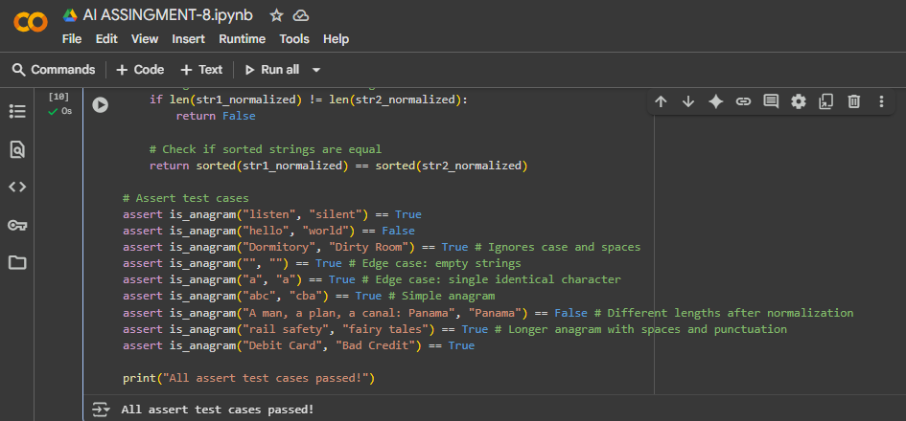
EXPLANATION:
